**Instructions to Run the Application**

Browse this URL: <https://dev.mysql.com/downloads/workbench/> and download the mysql workbench as shown below

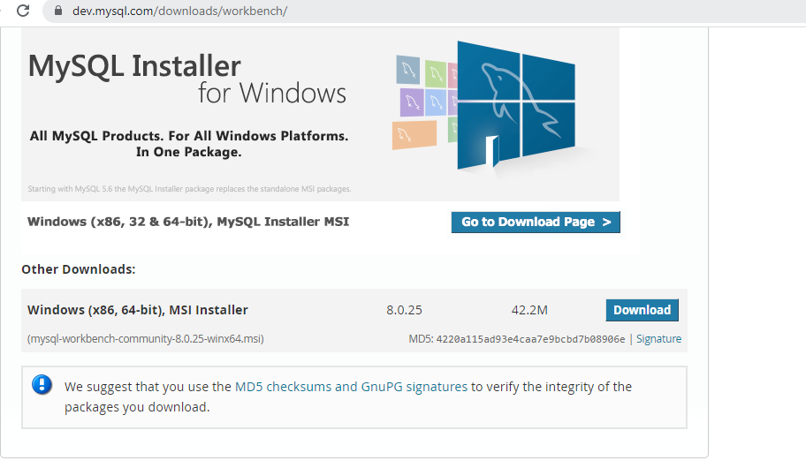

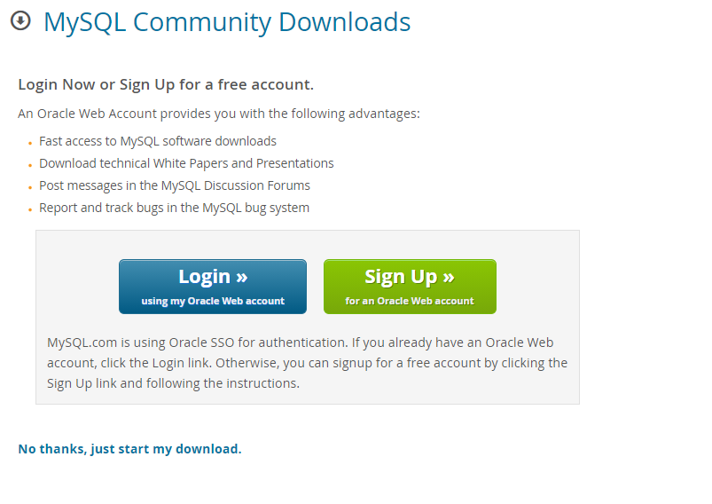

**1.**First step is launching the Workbench MySQL. What you see is called **Home Window**

**[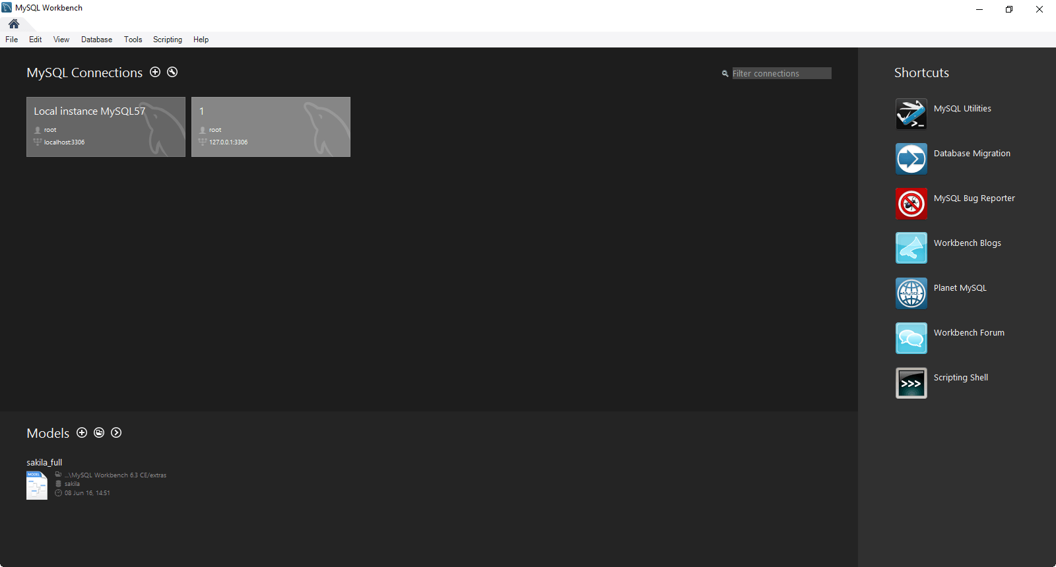](https://www.guru99.com/images/mysql_work_bench_home.png)**

2. Next you need to create your MySQL Server Connection which contains details about target database server including how to connect to it. Click **" +  "** in MySQL Workbench Home Window. This will open **Setup New Connection**. Wizard

[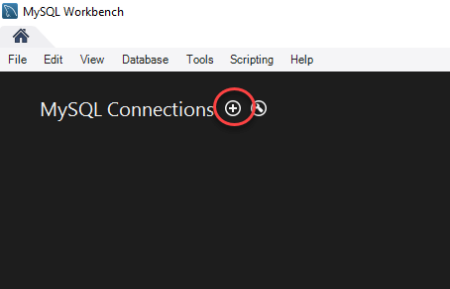](https://www.guru99.com/images/workbench-instance-1.png)

3. As a beginner you can create a connection for a locally installed server. Click **Configure Server Management**button in **Setup New Connection** window to check the cofiguration of the MySQL server.

[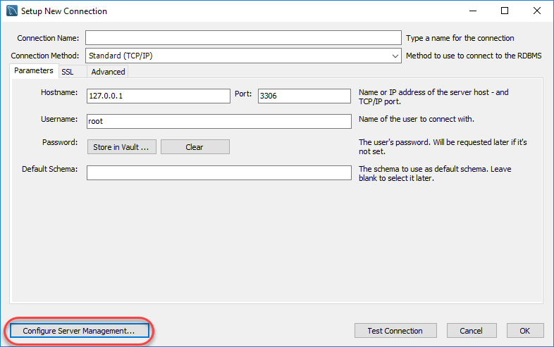](https://www.guru99.com/images/workbench-instance-2.png)

4. A new window opens named **Configure Local Management**. Click Next button to continue.

[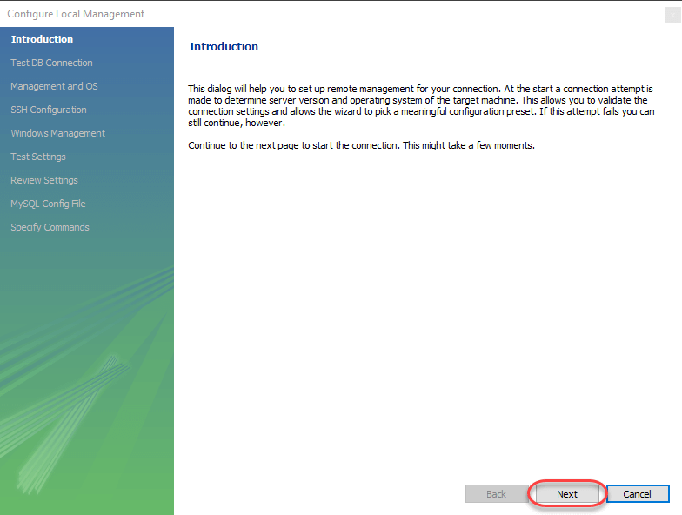](https://www.guru99.com/images/workbench-instance-3.png)

5. Next the Wizard will test connections to database. If test fails, go back and correct database connection parameters.5. Next it will open a pop up window asking your root password to test your connection with the local mysql server instance. The password is the one you set during installation of MySQL Workbench. Enter your password and press **OK**

[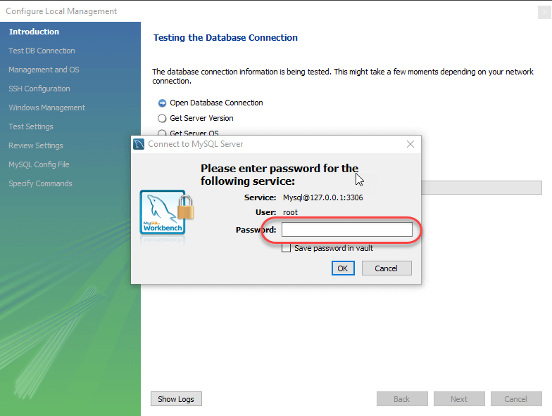](https://www.guru99.com/images/workbench-instance-4.png)

6. Next the Wizard will test connections to database. If test fails, go back and correct database connection parameters. Else if all tests are sucessful click Next to continue.

[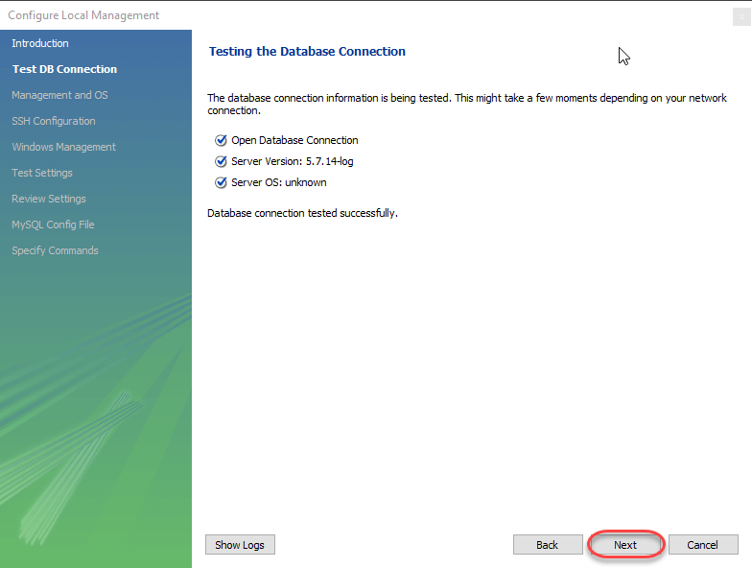](https://www.guru99.com/images/workbench-instance-5.png)

7. After that a new wizard will open about Local Service Management - It lets you switch between multiple mysql severs installed on one machines. As a beginner you can bypass this and click **Next** to continue.

[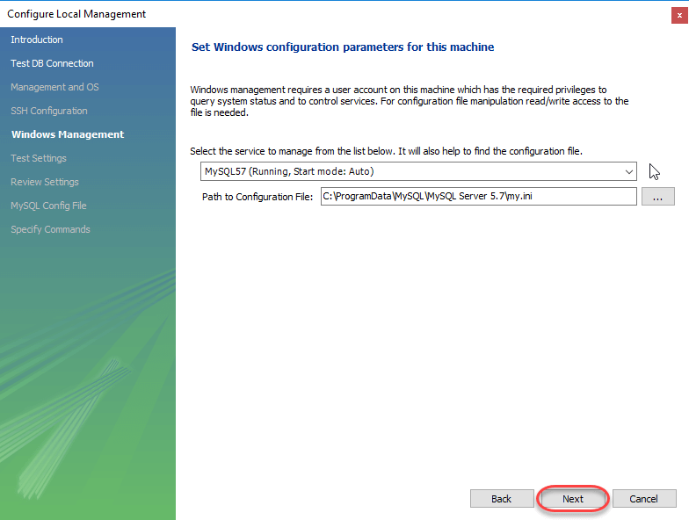](https://www.guru99.com/images/workbench-instance-6.png)

8. The Wizard will then check ability to access MySQL Server Configuration File, and test start/stop commands.

[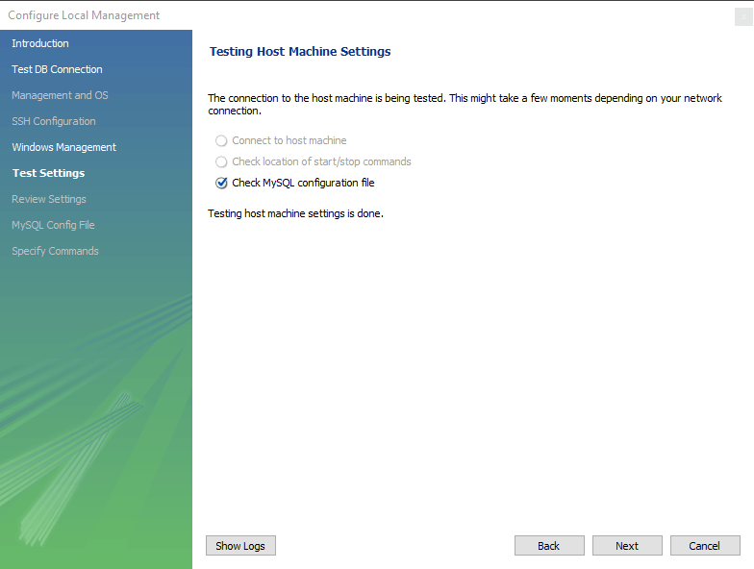](https://www.guru99.com/images/workbench-instance-7.png)

9. Next you can review current configurations. After reviewing the configurations, Click Finish to finsh server cofiguration

[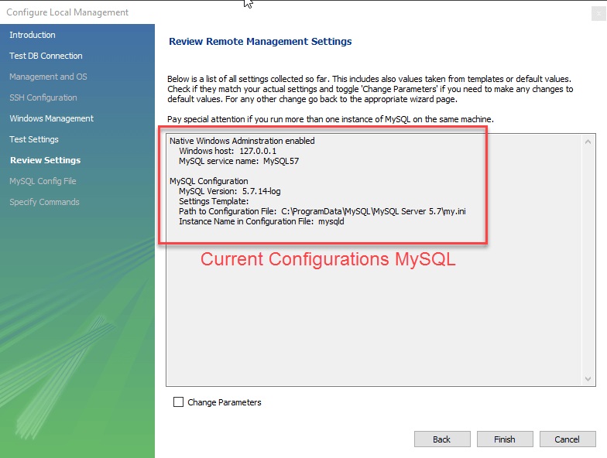](https://www.guru99.com/images/workbench-instance-7-1.png)

10. Next Step is to setup a connection, which can be used to connect to server. If you have not created a connection already, you can use the default values given. Click on Test Connection [ 2 ] after entering the Connection Name [ 1 ].

[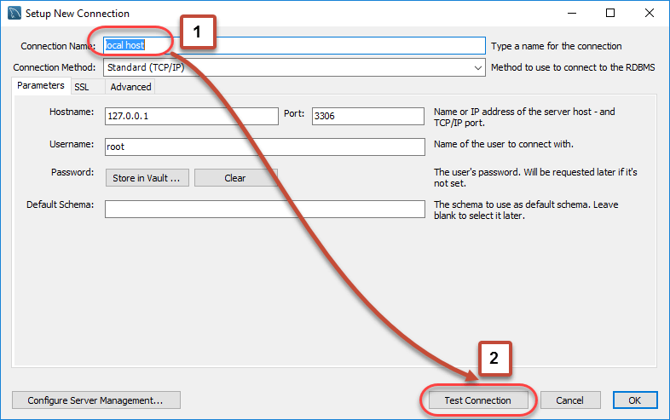](https://www.guru99.com/images/workbench-instance-8.png)

11. A new dialog box will open asking you password to root/selected user. If your MySQL root user has a password, you can enter that using Store in Vault feature. Click OK.

[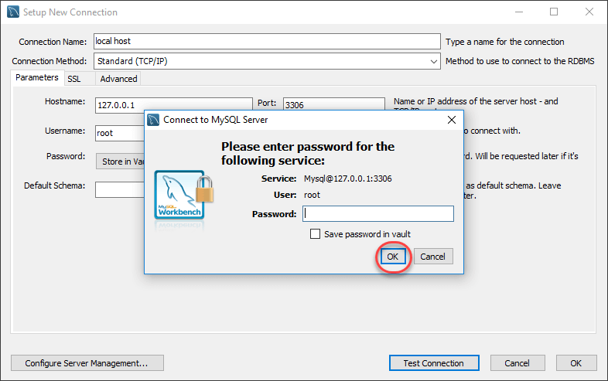](https://www.guru99.com/images/workbench-instance-9.png)

If the entered password for the user is correct then the following screen will show. Click on **both OK** buttons and you will be good to go.

[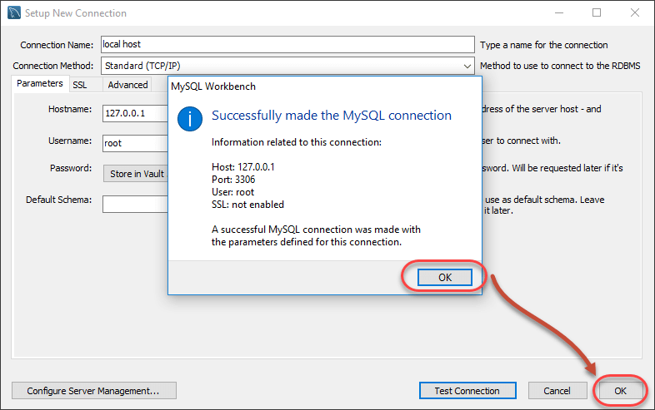](https://www.guru99.com/images/workbench-instance-10.png)

A new instance is shown in the homepage.

[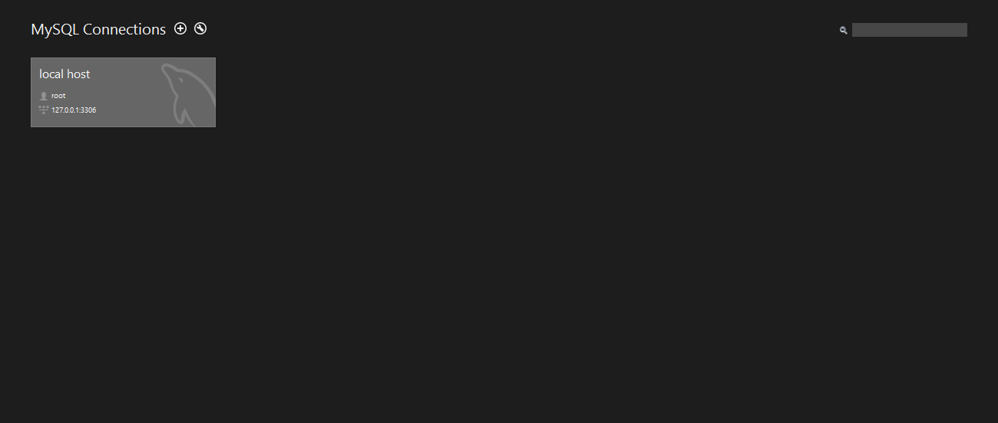](https://www.guru99.com/images/workbench-instance-11.png)

Open file and press the cntrl, shift + O to open SQL script

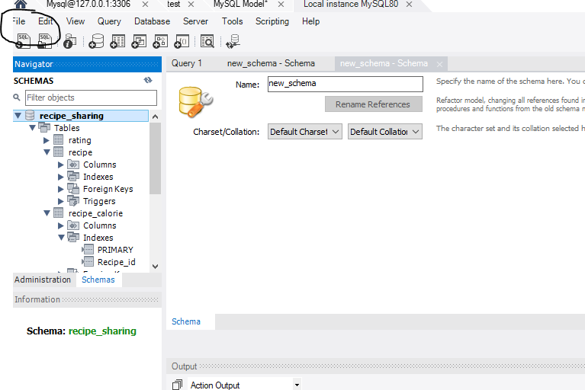

After selecting the sql file run the file as shown in the figure

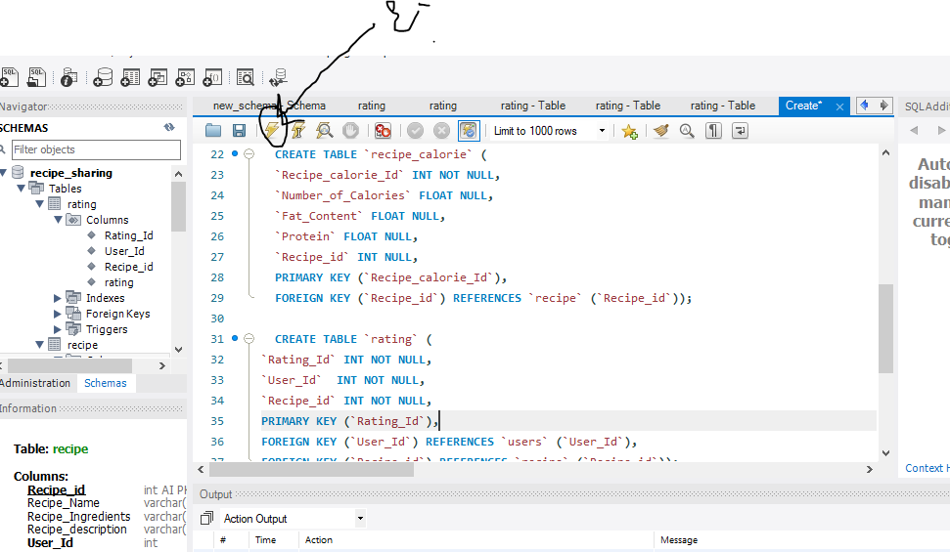

Now the tables are created in the backend.

Before creating the environment check the python and pip are installed. If not install it

Download the python 5 as shown below

1. Click [Python Download](https://www.python.org/downloads/).

The following page will appear in your browser.

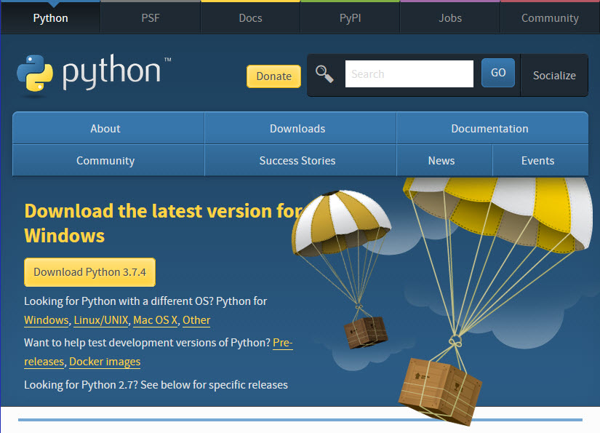

1. Click the **Windows** link (two lines below the **Download Python 3.7.4** button). The following page will appear in your browser.

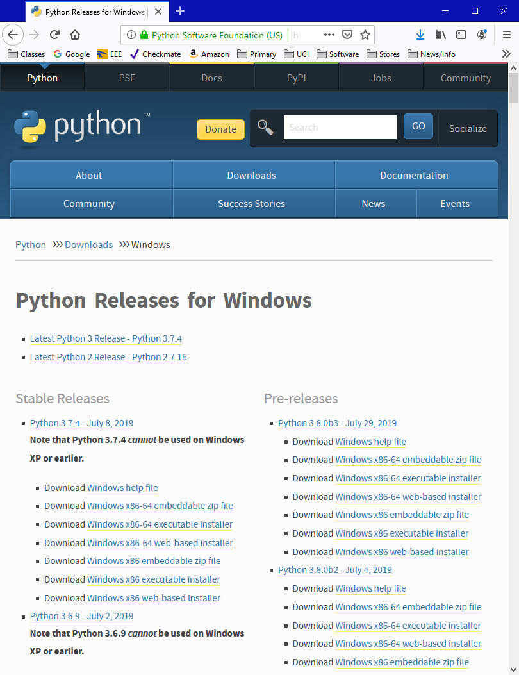

1. Click on the **Download Windows x86-64 executable installer** link under the top-left **Stable Releases**.

The following pop-up window titled **Opening python-3.74-amd64.exe** will appear.

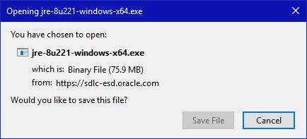

Click the **Save File** button.

The file named **python-3.7.4-amd64.exe** should start downloading into your standard download folder. This file is about 30 Mb so it might take a while to download fully if you are on a slow internet connection (it took me about 10 seconds over a cable modem).

The file should appear as

https://www.ics.uci.edu/~pattis/common/handouts/pythoneclipsejava/images/python/exefile.jpg

1. Move this file to a more permanent location, so that you can install Python (and reinstall it easily later, if necessary).
2. Feel free to explore this webpage further; if you want to just continue the installation, you can terminate the tab browsing this webpage.
3. Start the **Installing** instructions directly below

**Installing**

1. Double-click the icon labeling the file **python-3.7.4-amd64.exe**.

A **Python 3.7.4 (64-bit) Setup** pop-up window will appear.

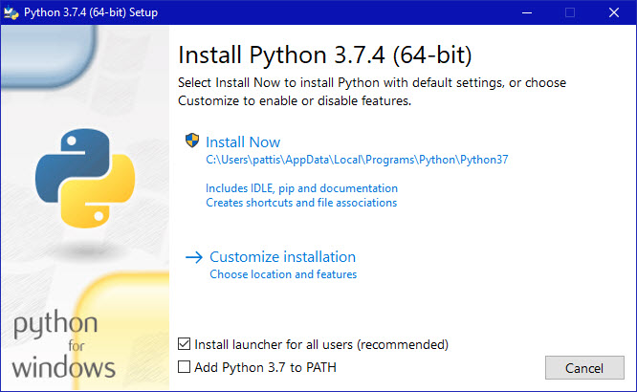

Ensure that the **Install launcher for all users (recommended)** and the **Add Python 3.7 to PATH** checkboxes at the bottom are checked.

If the Python Installer finds an earlier version of Python installed on your computer, the **Install Now** message may instead appear as **Upgrade Now** (and the checkboxes will not appear).

1. Highlight the **Install Now** (or **Upgrade Now**) message, and then click it.

When run, a **User Account Control** pop-up window may appear on your screen. I could not capture its image, but it asks, **Do you want to allow this app to make changes to your device**.

1. Click the **Yes** button.

A new **Python 3.7.4 (64-bit) Setup** pop-up window will appear with a **Setup Progress** message and a progress bar.

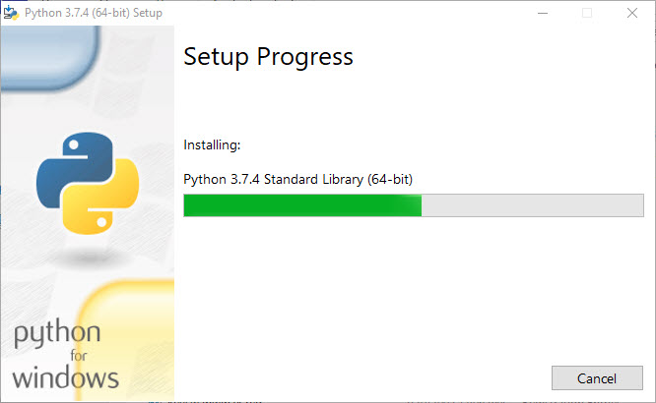

During installation, it will show the various components it is installing and move the progress bar towards completion. Soon, a new **Python 3.7.4 (64-bit) Setup** pop-up window will appear with a **Setup was successfuly** message.

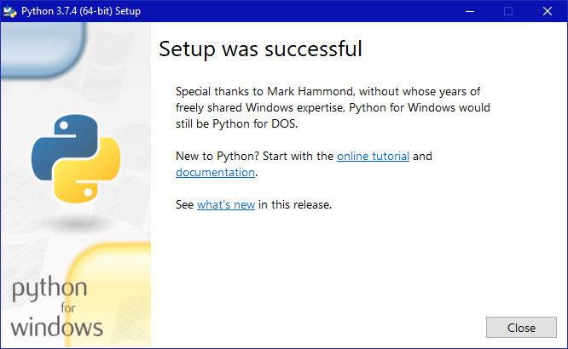

1. Click the **Close** button.

Python should now be installed.

**Verifying**

To try to verify installation,

1. Navigate to the directory **C:\Users\Pattis\AppData\Local\Programs\Python\Python37** (or to whatever directory Python was installed: see the pop-up window for Installing step 3).
2. Double-click the icon/file **python.exe**.

The following pop-up window will appear.

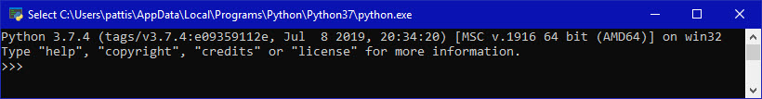

A pop-up window with the title **C:\Users\Pattis\AppData\Local\Programs\Python\Python37\python.exe** appears, and inside the window; on the first line is the text **Python 3.7.4 ...** (notice that it should also say 64 bit). Inside the window, at the bottom left, is the prompt **>>>**: type **exit()** to this prompt and press **enter** to terminate Python.

You should keep the file **python-3.7.4.exe** somewhere on your computer in case you need to reinstall Python (not likely necessary).

You may now follow the instructions to download and install Java (you should have already installed Java, but if you haven't, it is OK to do so now, so long as you install both Python and Java before you install Eclipse), and then follows the instruction to download and install the Eclipse IDE. Note: you need to download/install Java even if you are using Eclipse only for Python)

**(1) Creating Environment for Project**

**Step-1:** Create an environment. Create a project folder and a venv folder within it.

**py -3 -m venv venv**

**Step-2:** Activate the environment.

**venv\Scripts\activate**

**Step-3:** Install Flask.

**pip install Flask**

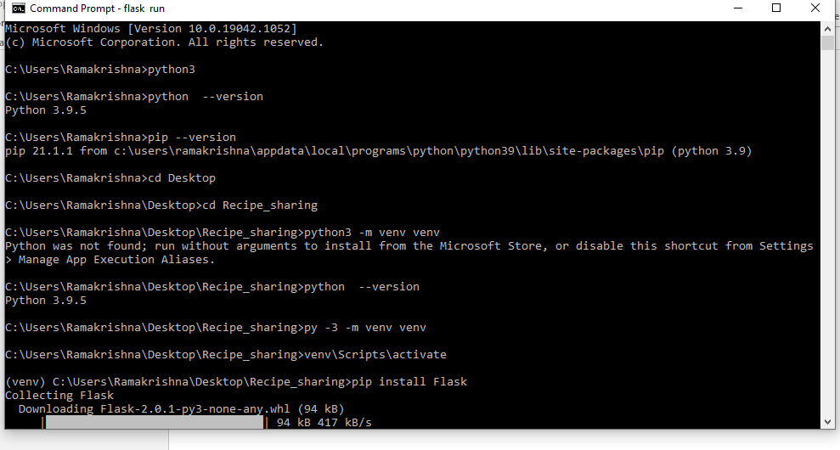

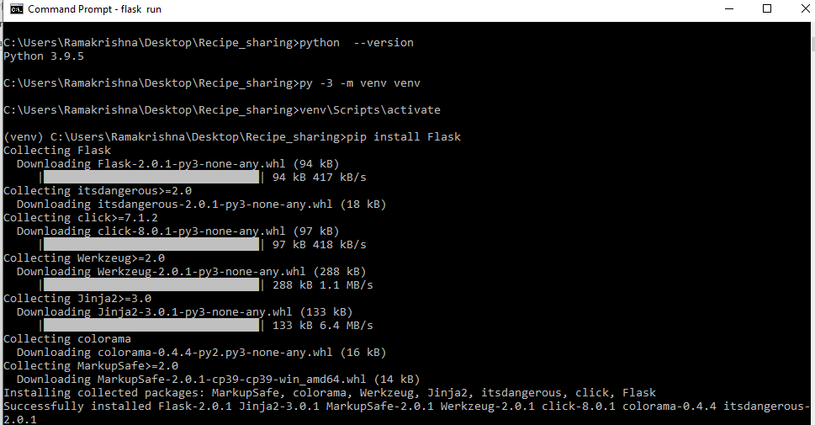

**To run the application use: flask run**

**Use the path of the application where the project**

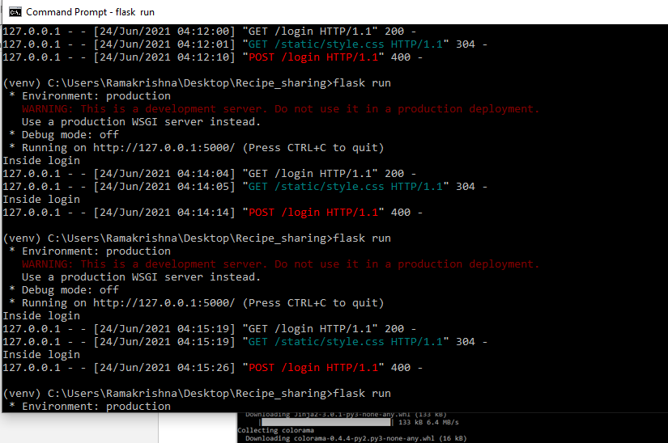

**Screenshots of web application:**

**LOGIN PAGE:** Here it performs the searching functionality whether the credentials entered by the user is presented in the users table where one of functionality is covered

**Functionality Covered**: Search

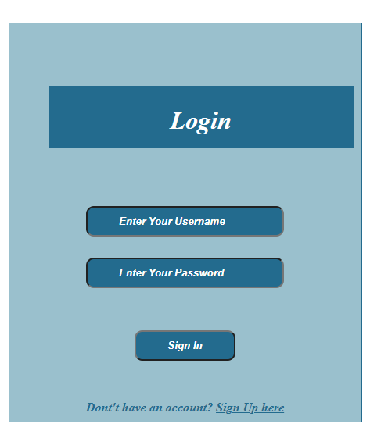

**Register Page:** Here we are entering the user details into the users table where the functionality of insert is performed

**Functionality Covered**: Insert

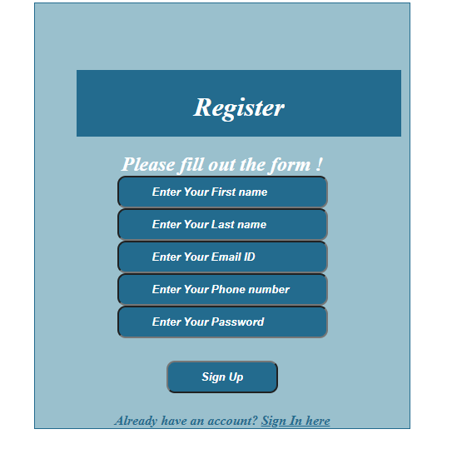

**Index Page:** This page redirects to the adding of recipe and recipe feed based on the user selction.

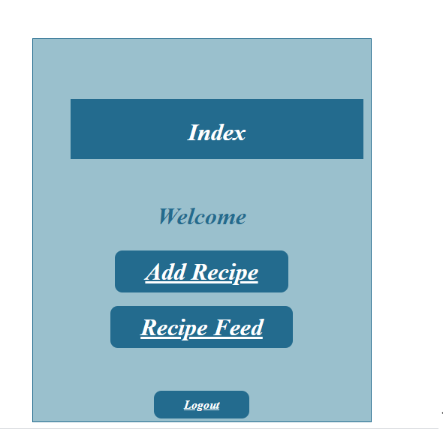

**Recipe:** Here we are inserting the data into the recipe table where we are storing data which covers the functionality of inserting the data

**Functionality Covered:** Insert

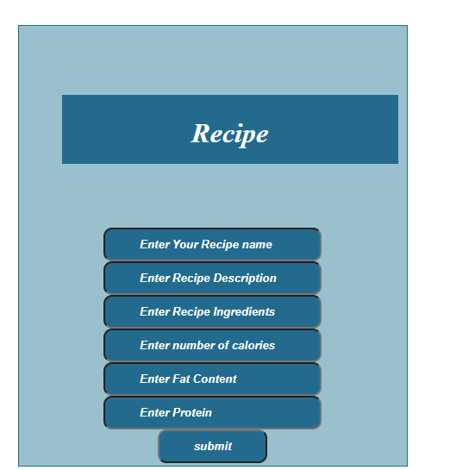

**Recipe Feed:** Here we are retrieving the data from the recipe where we are covering other functionality of retrieving.

**Functionality Covered**: Retrieving the data

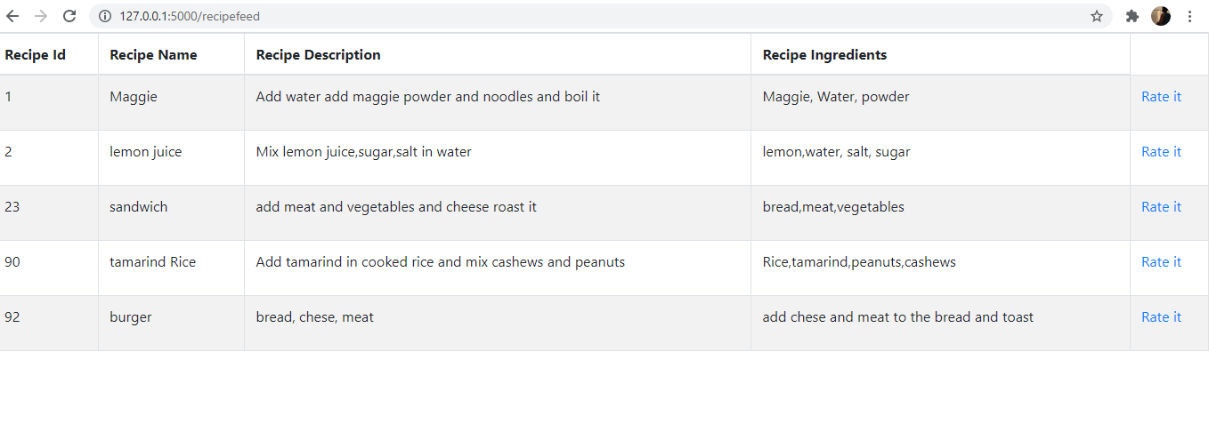

**Rating**

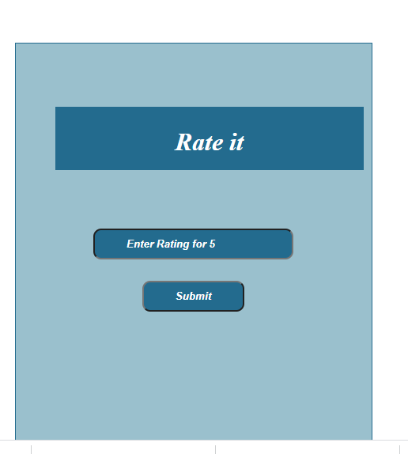

**Result:** From the above all screenshots we have achieved the all 3 operations specified.

**SCREENSHOTS OF DATABASE**

**RECIPE TABLE**

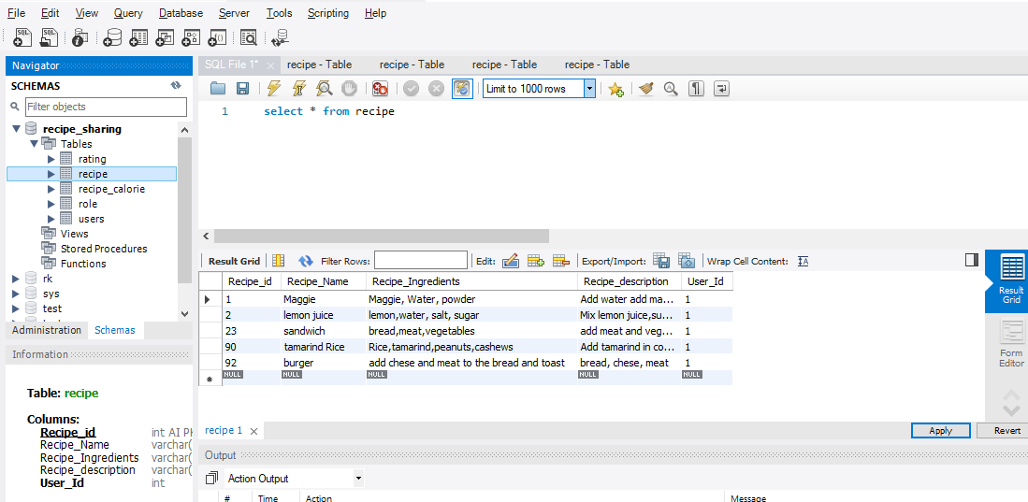

**RECIPE CALORIE TABLE**

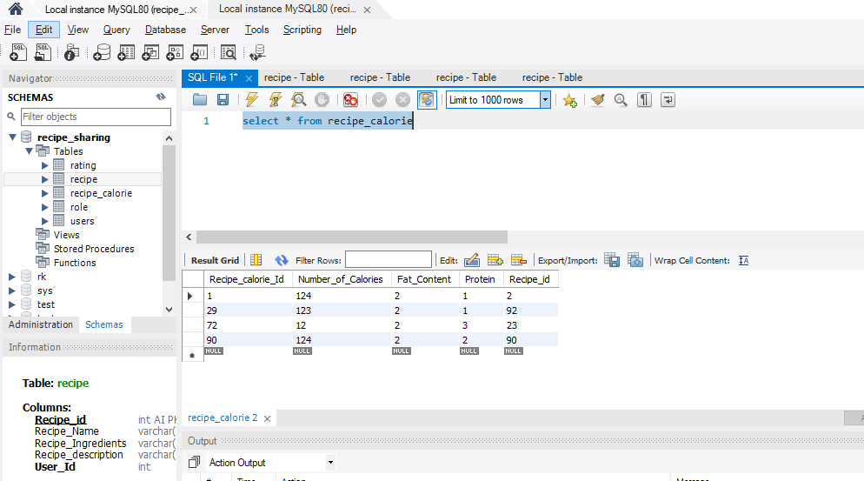

**RATING TABLE**

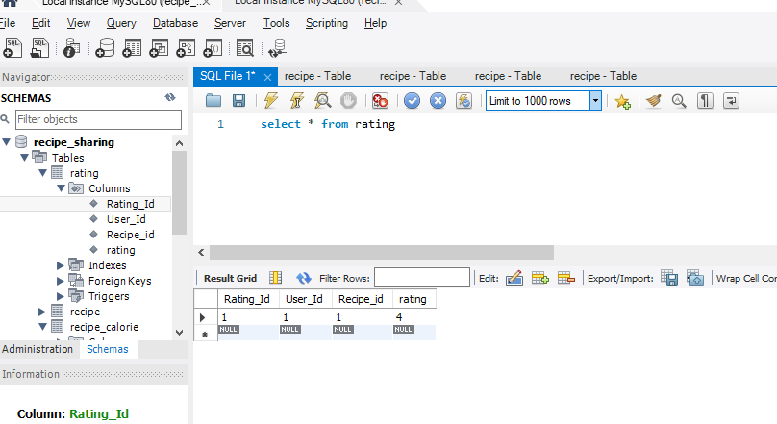

**Users Table**

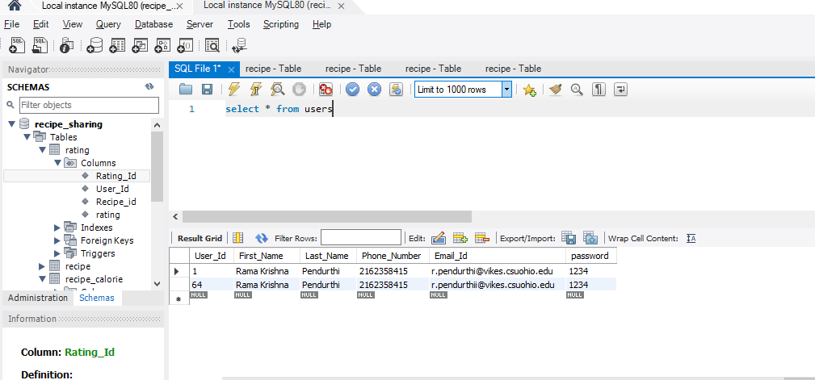

**ROLE TABLE**

